Task 1.1 Apache Kafka – Summary

Introduction
Apache Kafka is a distributed event streaming platform that is mainly used for handling real-time data and communication between different services or applications. It helps systems send, store, and process large amounts of messages efficiently. Kafka is widely used in modern applications such as ride-booking systems, banking systems, e-commerce platforms, and real-time analytics.

Topic
A topic in Kafka is similar to a category where messages are stored. Producers send data to topics, and consumers read data from those topics. Topics help organize messages based on their purpose. Examples: orders, payments. In an e-commerce application, all order-related events can be stored inside an orders topic.

Partition
Kafka topics are divided into smaller sections called partitions. Partitions help Kafka process data faster because multiple consumers can work on different partitions simultaneously. Partitions also help Kafka scale efficiently when handling a very large amount of real-time data.
Orders
├ Partition 0
├ Partition 1

Offset
Every message stored inside a partition is assigned a unique sequence number called an offset. Offsets help Kafka identify the exact position of each message.
Example:
- Offset 0 → Order Created
- Offset 1 → Payment Successful
- Offset 2 → Order Delivered

Broker
A broker is a Kafka server responsible for storing messages and managing communication between producers and consumers. A Kafka system may contain one or more brokers depending on the application size. In my setup, Kafka was running inside a Docker container which acted as the broker.

Replication Factor
Replication factor refers to the number of copies maintained for each partition. Replication improves reliability and fault tolerance because backup copies are available if one broker fails. For local setup Replication Factor can be 1 but in real-world production systems, the replication factor is usually 2 or 3 for better reliability.

ISR (In-Sync Replicas)
ISR stands for In-Sync Replicas. These are replicas that are fully updated and synchronized with the leader partition. Kafka uses ISR to maintain consistency and ensure data reliability within the cluster.

Producer
A producer is an application or service that sends messages to Kafka topics. Producers generate events or data and publish them into Kafka.
Examples:
- Order Service
- Ride Booking Service
- Payment Service

Consumer
A consumer is an application or service that reads messages from Kafka topics and performs some action based on the received data. Consumers continuously listen for new events from Kafka. Examples Analytics Service, Notification Service, Billing Service. For example, when a ride is booked in a ride-sharing application, a notification service may consume the event and send notifications to the driver and rider.

Consumer Group
A consumer group is a collection of multiple consumers working together to process messages from a topic. Kafka automatically distributes partitions among consumers inside the same group. This improves scalability and processing speed.
Example:
- Consumer A → Partition 0
- Consumer B → Partition 1 and 2
ZooKeeper / KRaft
Older versions of Kafka used ZooKeeper to manage cluster coordination and metadata. Newer Kafka versions use KRaft mode, which removes the dependency on ZooKeeper and simplifies Kafka architecture. In my setup, Kafka was configured and executed using KRaft mode through Docker.

Conclusion
Apache Kafka is a powerful event streaming platform used for real-time communication between services and applications. Concepts such as producers, consumers, topics, partitions, offsets, and consumer groups help Kafka process large-scale real-time data efficiently. Kafka is widely used in modern distributed systems because of its scalability, reliability, and high performance.

Task 1.2 – Kafka Local Setup

A local Apache Kafka environment was successfully set up using Docker Compose in KRaft mode.

Broker Started
Kafka broker was started using the command:
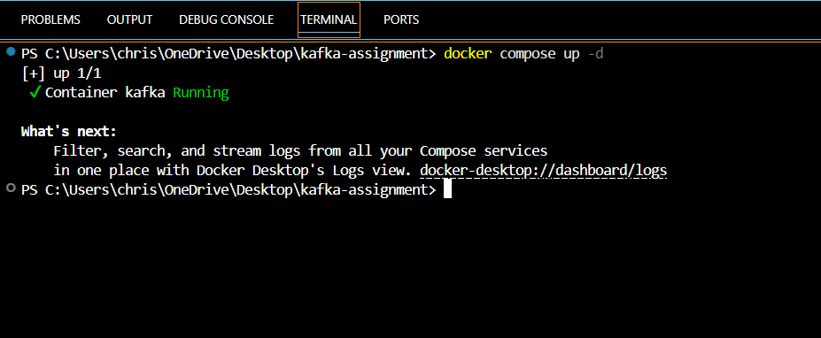
docker compose up -d

The running Kafka container was verified using:
docker ps
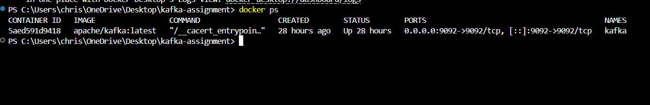

Topic Created
A topic named orders-demo was created with 3 partitions and replication factor 1.
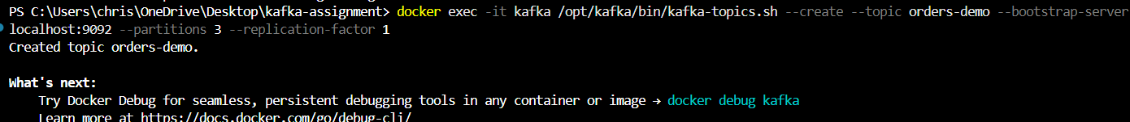
docker exec -it kafka /opt/kafka/bin/kafka-topics.sh --create --topic orders-demo --bootstrap-server localhost:9092 --partitions 3 --replication-factor 1

Message Produced
Messages were produced using Kafka console producer.
docker exec -it kafka /opt/kafka/bin/kafka-console-producer.sh --topic orders-demo --bootstrap-server localhost:9092
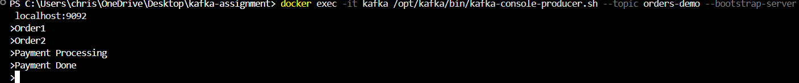

Message Consumed
Messages were consumed using Kafka console consumer.
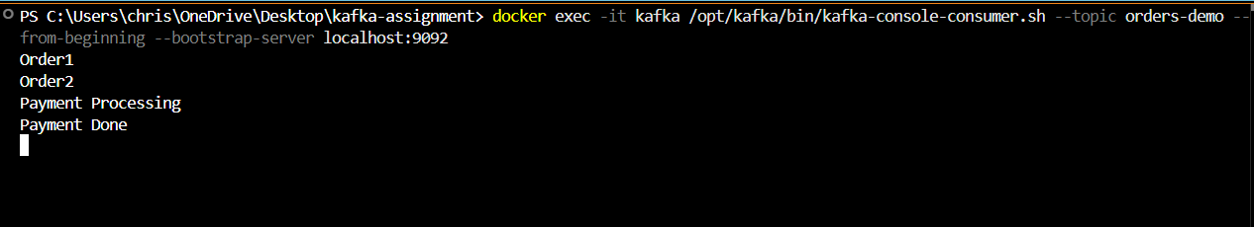
docker exec -it kafka /opt/kafka/bin/kafka-console-consumer.sh --topic orders-demo --from-beginning --bootstrap-server localhost:9092

Observation: The producer successfully published messages to the Kafka topic, and the consumer successfully received and displayed the messages from the topic.
Task 1.3 – Topic Creation and Partition Observation

Topic Creation
A Kafka topic named customer-orders was created with 3 partitions and replication factor 1 using the following command:
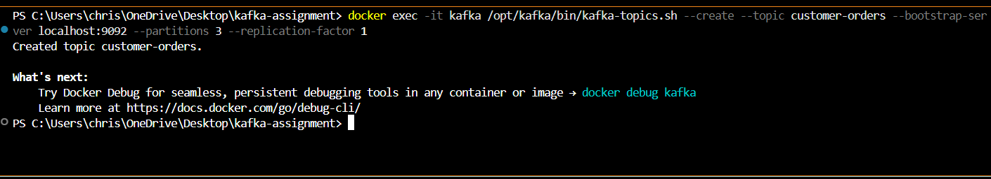
docker exec -it kafka /opt/kafka/bin/kafka-topics.sh --create --topic customer-orders--bootstrap-server localhost:9092 --partitions 3 --replication-factor 1

Producing Messages
Messages were produced into the customer-orders topic using Kafka console producer.
docker exec -it kafka /opt/kafka/bin/kafka-console-producer.sh --topic customer-orders--bootstrap-server localhost:9092
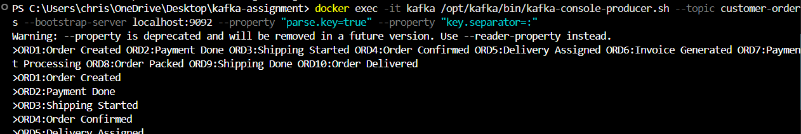

Consuming Messages from Partition 0
Messages were consumed specifically from Partition 0 using the following command:
docker exec -it kafka /opt/kafka/bin/kafka-console-consumer.sh --topic customer-orders--partition 0 --from-beginning --bootstrap-server localhost:9092
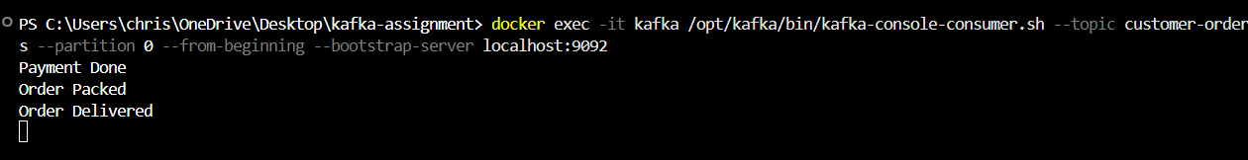
Observation
The topic was divided into 3 partitions, and Kafka distributed messages among these partitions automatically. While consuming messages only from Partition 0, only a few messages were displayed because the remaining messages were stored in other partitions.
This task helped in understanding how Kafka partitions work and how message distribution improves scalability and parallel processing.

